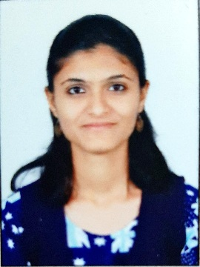

Name | Ms. Deepali Balasaheb Tajanpure
Department: | Science
Designation | Laboratory Assistant
Email: | dbtajanpure@kkwagh.edu.in  tajanpuredeepali@gmail.com
Education | Msc (organic chemistry )
Experience | One year experience in water testing as an analyst and 8 months experience in petrochemical company as an chemist in Quality Control department
Research Area(s) | No.
Publications: Paper/Copyright/Patent/Grant received | No.
Contents developed | No.
Membership of professional bodies | No.
Awards | No.
Key Research Projects | No.

