K. K. Wagh Institute of Engineering Education and Research

**Department of Production Engineering**

**Technical News Letter**

March 2022 of AY 2021-22

It’s a great pleasure to present our newsletter for the March 2022 of AY 2021-22. Department of Production Engineering has been consistently endeavoring to upgrade the skills and performance of students and staff members through various ventures.

* **Expert lectures attended by staff**

03 expert lectures attended by the teaching and non- Teaching staff.

|  |  |  |  |  |  |
| --- | --- | --- | --- | --- | --- |
| **Sr.No.** | **Title of lecture** | **Name of Speaker** | **Name of Industry** | **Date** | **No. of Student Present** |
| 1 | Warehousing Operations | Mr.Mayuresh Jahagirdar | GreenOrangePvt. Ltd. Nashik | 9-3-2022 | 25 |
| 2 | Insights of Documentation for Product Process | Mr. Pradip Sharma | J.P. Enterprises, Nashik | 19-3-2022 | 61 |
| 3 | Intellectual Property Right(IPR) | Mr. Santosh B. Sangle | Patent Analytics and Drafting, Pune | 24-3-2022 | 77 |

* **Training Completed by faculty**

01 Training Completed by faculty

|  |  |  |  |  |
| --- | --- | --- | --- | --- |
| Sr. No. | Name of faculty | Designation | Training Name | Conducted By |
| 1 | V. S. Gaikwad | Assistant Professor | FDP on Electronic System Design during 22/3/2022 to28/3/2022 | AICTE Idea Lab at Netaji Subhas University of Technology, Delhi |

* **Robotics Club**

Robotics club at institute level has been inaugurated at the hands of Principal Dr. K.N. Nandurkar on 2nd March 2022. For the function all the staff members of department of Robotics and Automation, Department of Production Engineering, and students from various departments were present. Dr. K.N. Nandurkar, guided all the members present during this occasion. Dr. P.J. Pawar, Head of Department, briefed about scope and proposed activities of the robotics club.

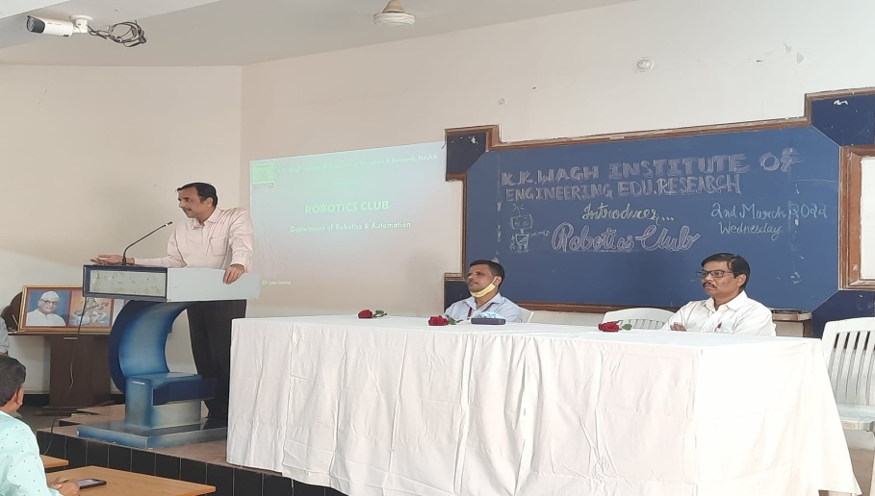

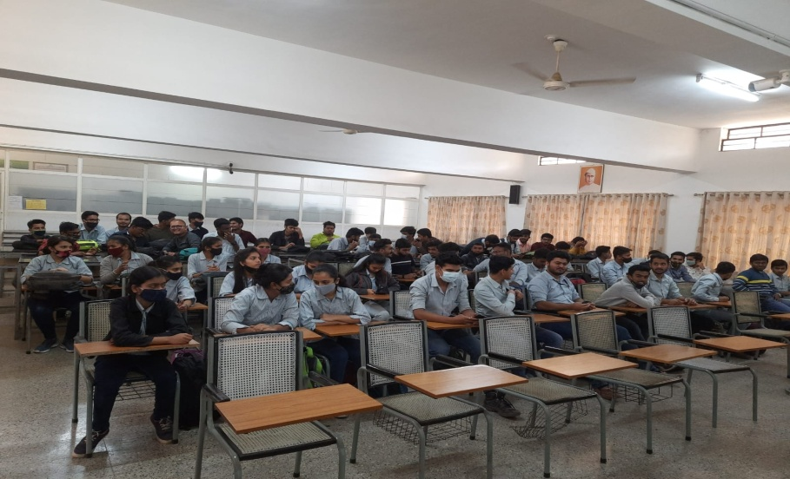

* **Robotics Awareness Workshop**

Robotics is one of the emerging technologies and Robotic science has a tremendous scope as a career option. Hence, to create awareness among students about Robotics and its applications, Department of Robotics and Automation conducted four awareness programs in the month of March for final year students of K. K. Wagh Polytechnic, Nashik. So far this program is attended by around160 students of Mechanical and Electrical engineering. These programs cover a theory session on Robotics followed by practical demonstrations on industrial robots and kits.

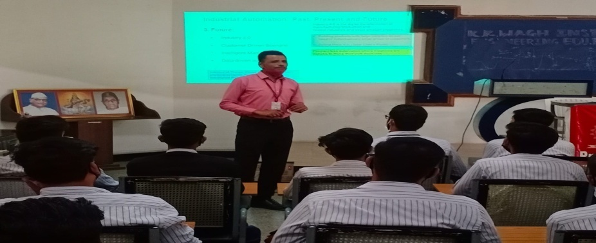

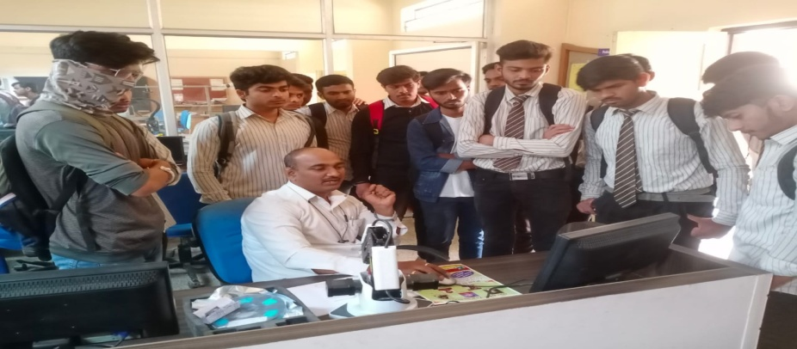

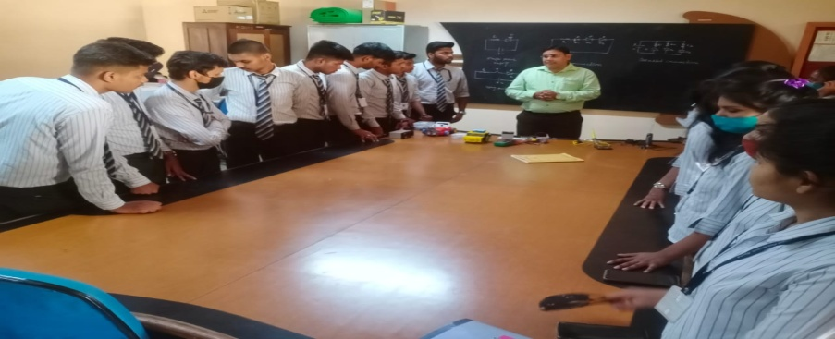

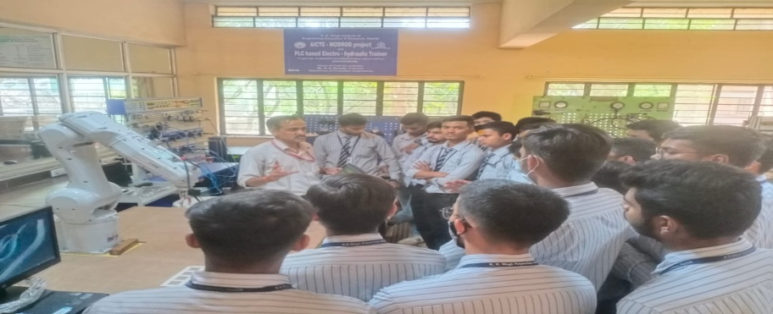

* **Online Webinar attended by the faculty**

In the month of the March 2022 teaching and non- Teaching staff member attended various webinar on online platform to explore the new advancement in the technology.

* **Student Visit**

To get exposure to industrial scenario in and around Nasik, students of SE Robotics and Automation visited to AIMA index 2022 on 19th march 2022. Students get insights into various practical aspects of the subjects they learned.

**Dr. P.J. Pawar**

**Head of the Department**