Activity Report (news bulletin) of IT Dept. for January 2021

- Expert Lecture/Seminar/Courses Organized by Department during January 2021:

Dept. of Information Technology had organized an online seminar on “Block Chain & Use Cases” by Mr. Gaurav Somwanshi, Columnist Writer of Loksatta & CEO & Cofounder at EmerTech Innovation on 28th Jan. 2021.

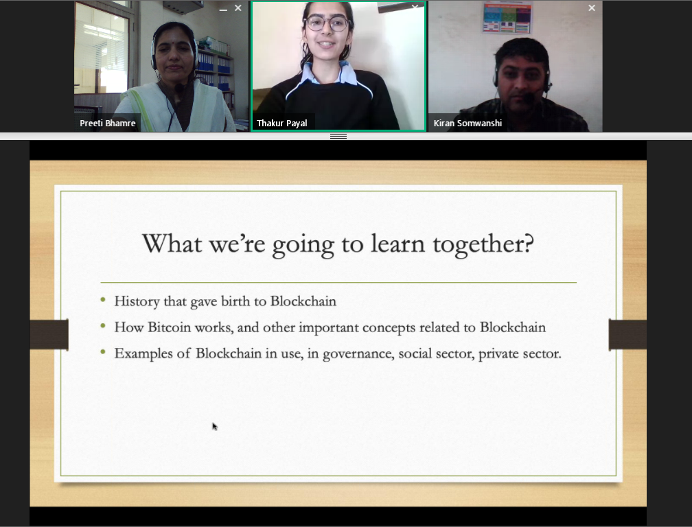
Seminar on “Block Chain & Use Cases” ” by Mr. Gaurav Somwanshi

- Papers Presented/Published in the Journal by Staff during January 2021:
Title of Paper: Systematic and Rigorous Use of Feedback to Enhance Learning in Engineering Classes
Name of Conference: The Eighth International Conference on Transformations in Engineering Education (ICTIEE 2021)
Name of Journal: Journal of Engineering Education Transformations
Volume and issue : Volume 34, January 2021

Dates: 8th to 10 Jan. 2021
eISSN: 2394-1707
Names of Authors: Preeti Bhamre, Apurv Vaidya, Jagruti Nikam
Abstract: Feedback is among the most common features of successful teaching and learning. Feedback aims to reduce the gap between where the students are and where they are meant to be. In order to bridge this gap, teachers must incorporate feedback in classroom effectively. There is a need to understand different ways in which feedback can be provided in classroom. There is also a need to identify and implement simple yet systematic procedure to provide regular and transparent feedback in classroom. This study presents deliberate use of spaced questioning to understand how to take full benefits from feedback in the classroom. Feedback is summarized based on the errors committed by the students. Instead of considering the errors simply as deficit of knowledge or inability of students to think correctly, they can be treated as opportunities to bridge the gap of what students know and what they should know. Knowing and acknowledging these errors is the key contribution of a teacher, which can be attained through feedback in classroom. The participants in this study were first year engineering students of 14 classes, enrolled for the Engineering Mechanics course. An ICT tool named MKCL SuperCampus, was used to pose questions and to track real time individual performance in the classroom. The use of the ICT tool provided an easy and fearless environment for students to participate comfortably, thereby motivating them to make and learn from errors and to engage more while learning in classes
Keywords: Information and Communication Technology (ICT), Teaching-Learning, Instruction, Formative assessment, Learning outcomes

Title of Paper: Student Centred Learning Using Student’s Learning Style
Name of Conference: The Eighth International Conference on Transformations in Engineering Education (ICTIEE 2021)
Name of Journal: Journal of Engineering Education Transformations
Volume and issue : Volume 34, January 2021

Dates: 8th to 10 Jan. 2021
eISSN: 2394-1707
Names of Authors: Pratik R. Kadam, Umesh K. Gaikwad , Preeti D. Bhamre
Abstract: Traditional and modern teaching methodologies focus less on the learning style of a student. In countries like India, the average strength of the class is 60 and it becomes very difficult to focus on each student individually. Instead of being student centric, the current engineering education system is more teacher-centric. It is inappropriate to assume that the same learning methodology is applicable to all students. There should be an attempt to customize the lecture delivery method or teaching style suitable to address heterogeneous learners in the classroom. This study explores how one can use some part of cognitive psychology to determine the learner bias i.e. learning styles of each student which can be used in customizing the delivery of subject to make it more student centric. In this proposed methodology visual, auditory and kinaesthetic (VAK) Model is used to determine learning style of the students. Depending upon the learning style of students, teacher modifies the classroom delivery methodology. Students are also provided learning resources and assignments based on their learning style. This approach is being tested on three different subjects of same class of second year engineering student of Information Technology. The test results post learning style methodology implementation are compared with earlier results for comparison. It has been observed that there is a notable improvement in the overall learning of each student. The implementation of student centred learning when aligned with the learning style of students can create a great impact on student’s performance.
Keywords:
VAK model, learning styles, heterogeneous learner, learning models

- Papers Presented by Students during January 2021: NIL
- Industrial Training/Workshop done by Staff during January 2021:
Prof. Pratik Kadam completed Coursera Certification on "Reliable Google Cloud Infrastructure: Design and Process" offered by Google Cloud.

Prof. Rupali Bora attended six days Short Term Training Programme (STTP) on “Leveraging Artificial Intelligence and Data Analytics for Healthcare” organized by Department of Information Technology, K J Somaiya Institute of Engineering & Information Technology,Mumbai sponsored by AICTE under AQIS 2019-20 from 4th to 9th Jan. 2020.

Prof. Pratik Kadam participated in “Google Cloud Community Days India” event organised by GDG Cloud Communitie from 22nd to 23rd Jan.2021.

- Industrial Visit organized by department for student during January 2021: NIL
- Training and Placement Cell during January 2021: NIL
- Books Purchased in Central Library during January 2021: NIL
- Forthcoming event in the month February and March 2021:-
- Achievements:
Prof. Pratik Kadam, Prof. Umesh Gaikwad and Dr. Preeti Bhamre received the Best Paper Award Certificate from ICTIEE 2021 Team for the paper titled “Student Centred Learning Using Student’s Learning Style” on 8th to 10 Jan. 2021.

Prof. Umesh Gaikwad had worked as resource person for Faculty Orientation Program on subject Computer Graphics(Theory) and CG Laboratory(Practical) organized by BOS IT SPPU, Pune with KBTCOE on 30th Jan. 2021

H.O.D., IT

