Name : Prof Ashwini Somnath Khaire

Date of Birth: August 13, 1991

**Educational Qualification:** ME (Electrical Power System) 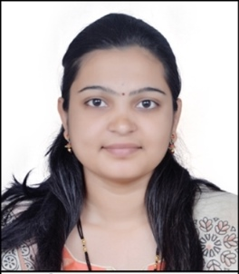

BE (Electrical Engg)

**Position:** Assistant Professor

**Phone Number:** +91 9503183922

**Email ID:** [askhaire@kkwagh.edu.in](mailto:askhaire@kkwagh.edu.in)

**Work Experience (Yrs):** 3 years

**Areas of Specialization**: Power Quality, Renewable Energy, Internet of Things

**Subjects Taught: UG Level:** Network Analysis, Power Electronics, Power Generation Technology, Smart Grid and Industrial Technology Management

**Number of Papers Published:** 04

**Number of Training Programs/Seminars/ Workshops/Conferences Attended:** 10

**UG Projects Guided:** 03

Place: **Nashik Prof Ashwini S Khaire**

Date: January 11, 2023

Assistant Professor