K. K. Wagh Institute of Engineering Education and Research

**Department of Production Engineering**

**Technical News Letter**

October 2021 of AY 2021-22

It’s a great pleasure to present our newsletter for the October of AY 2021-22. Department of Production Engineering has been consistently endeavoring to upgrade the skills and performance of students and staff members through various ventures.

* **Expert lectures attended by staff**

03 expert lectures attended by the teaching and non- Teaching staff.

|  |  |  |  |  |  |
| --- | --- | --- | --- | --- | --- |
| **Sr.No.** | **Title of lecture** | **Name of Speaker** | **Name of Industry** | **Date** | **No. of Student Present** |
| 1 | Soldmatic Welding Simulator | Mr. Adrian Macias Lopz | Aimil Partners Seabery for Providing Welding Training & performance Digitalization Solution | 1-10-2021 | 46 |
| 2 | Career Opportunities in Robotics in Automotive Sector | Mr. Rahul Mahajan, Nashik. | DGM, Mahindra and Mahindra | 14-10-2021 | 27 |
| 3 | Industrial Electrical Electronics Engineering | Ms. Sonali Shinkar | Nashik | 29-10-2021 | 22 |

* **Industrial Visits**

09 Industry visited by Staff.

|  |  |  |  |
| --- | --- | --- | --- |
| **Sr. No.** | **Date** | **Name of Industry** | **Name of staff visited to industry** |
| 1 | 26/10/2021 | Portescap India Pvt. Ltd. Unit no.2, sdf 1, seepz - sez, Andheri (e), Mumbai - 400096, India.  91-8291473130 | Prof.V.S.Gaikwad  Mr. A. R. More |
| 2 | 26/10/2021 | Highbar Technocrat Ltd  [Address](https://www.google.com/search?q=highbar+technocrat+limited+address&ludocid=1596870836425110334&sa=X&sqi=2&ved=2ahUKEwj-l_DXk73zAhVZqZUCHV9DBSwQ6BN6BAg6EAI): D-Wing, 14th Floor, Empire Tower Reliable Cloud City, Off, Thane - Belapur Rd, Airoli, Navi Mumbai, Maharashtra 400708, Ph[022- 2679 2000](https://www.google.com/search?q=highbar+technocrat+ltd&oq=HIGHBAR+TECHNOCRAT+LTD&aqs=chrome.0.0i355i512j46i175i199i512j0i22i30l5.9408j0j7&sourceid=chrome&ie=UTF-8) | Prof.V.S.Gaikwad  Mr. A. R. More |
| 3 | 26/10/2021 | Marketing Spectrum ethers Ltd, 201 saba palace, 2nd floor,4th road, khar west, Mumbai 52  9987722132 | Prof.V.S.Gaikwad  Mr. A. R. More |
| 4 | 26/10/2021 | Blue star limited,  bandbox house 4th floor, 254 d, Annie Besant road worli, Mumbai Mob.9600034725 | Prof.V.S.Gaikwad  Mr. A. R. More |
| 5 | 26/10/2021 | Tiaa, Mumbai  Home Add:- 1403, Avalon B Wing, Hiranandani, Powai, Mumbai 400076  98330 56243 | Prof.V.S.Gaikwad  Mr. A. R. More |
| 6 | 26/10/2021 | Vaxom packaging pvt. Ltd.,  92-d, dr. Babasaheb ambedkar road, kandivali,  Charkop industrial estate, kandivali west, Mumbai. Maharashtra-400067 Mob.9004699988 | Prof.V.S.Gaikwad  Mr. A. R. More |
| 7 | 27/10/2021 | Fab industries, Wadivarhe, Nashik | Prof. M.Y.Khalkar |
| 8 | 29/10/2021 | Gabriel Ltd. Abmbad MIDC, Nashik | Prof. M.Y.Khalkar |
| 9 | 28/10/2021 | Mungi Brothers, Plot No D, 15, MIDC Rd, Ambad Gaon, Nashik, Maharashtra 422010 Mob. 9922430048 | Dr. S. R. Gangurde |

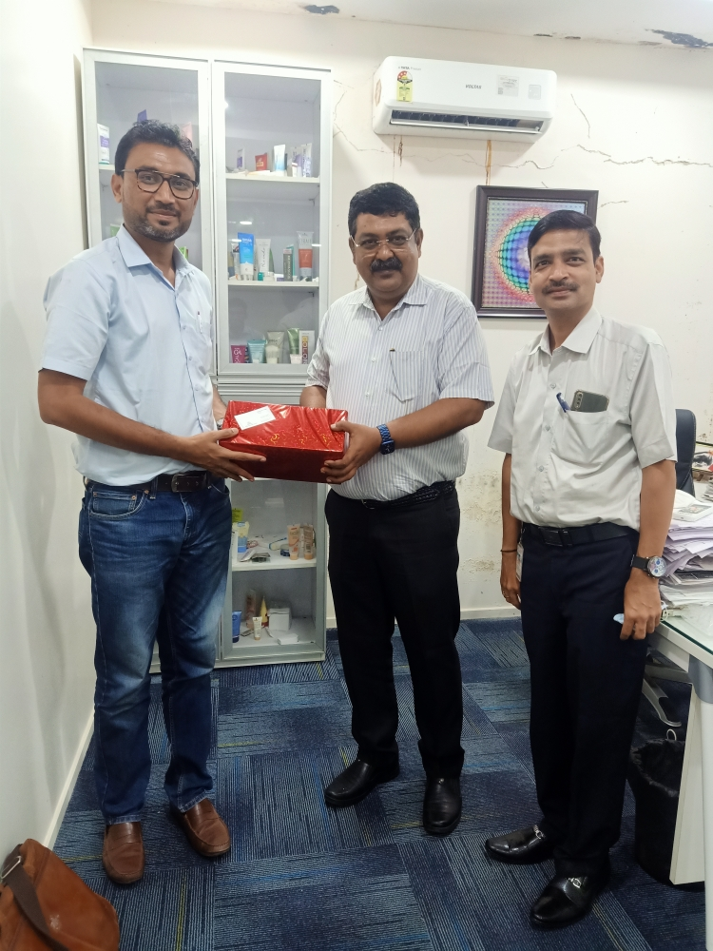

* **Online Webinar for students**

Department of Robotics and Automation organized webinar on "Career Opportunities in Robotics in Automotive Sector" on 14th October 2021. Mr. Rahul Mahajan (DGM, Mahindra and Mahindra, Nashik) the speaker of this webinar explored the application of robots in manufacturing as well as in service organization. He also explained about the role and importance of robots in automobile Industry.

**Online Webinar attended by the faculty**

In the month of the September 2021 teaching and non- Teaching staff member attended various webinar on online platform to explore the new advancement in the technology.

* **Students Achievement**

01 student of 2021-2022 batch select in Relience with package of 3.5lacs.

* **Staff Activities**

Department organized one day online workshop on Syllabus Implementation of TE (Production) 2019 Course syllabus. Five institutes of Savitribai Phule Pune University having Production Engineering branch participated in this workshop. Dr. K. N. Nandurkar, Chairman of the board of studies (Production and Industrial Engineering) delivered welcome address and guided the participants on various issues of syllabus implantation.

**Expert lectures delivered:**

1. Dr. P. J. Pawar delivered an expert talk on ‘Advanced Engineering Optimization’ organized by SVNIT Surat on 18/10/2021 and 20/10/2021

**Dr. P.J. Pawar**

**Head of the Department**