**K.K. Wagh Institute of Engineering Education & Research**

**Department of Civil Engineering**

Bio Data

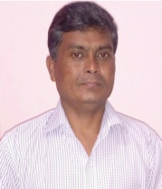

|  |  |  |  |
| --- | --- | --- | --- |
| 1. | Name: | **:** | **Pramod Dhondiram Niphade.** |
| 2 | Address: |  | At/Post : Shirwade Vani. Tal: Niphad ,Dist :Nashik. |
| 3 | Date of Birth |  | 02/06/1972. |
| 4 | Phone No. | **:** | 9623104829. |
| 5 | Email | **:** | pdniphade@kkwagh.edu.in |
| 6 | Educational Qualification: | **:** | D.C.E. |
| 7 | Date of Joining In Institute | **:** | 24/8/2004. |
| 8 | Designation | **:** | Technical Assistant. |
| 9 | Work Experience | **:** | Industrial (Civil): 8Years.  Educational: 14 Years.  14 Years |
| 10 | Workshop / Seminar attended | : | Three days Workshop by HRD.  Seminar on Dead Stock Management.  Workshop on soft Skill.  Workshop on MS Excel. |
| 11 | Skills. |  | Experience in Building Construction. |
| 12 | IT Proficiency  ❖ MS – CIT | : | MS-CIT |

|  |
| --- |
|  |
|  |