Name : Suhas U. Pandit

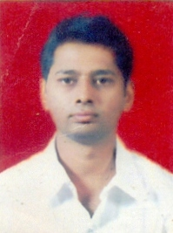

Contact Number :9423740490

Email : supandit@kkwagh.edu.in

Designation :Assistant Professor

Qualification :B.E. Civil , M.E. (Construction Management)

Total teaching experience :7Years 9Months

Papers Published

International Journals: Nil National Journals: Nil

Papers Published

International Conferences: 02 National Conferences: 01

STTP Attended: 07

Conferences attended: 01