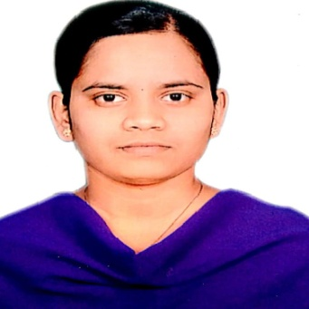

**Wable PUJA DILIP**

**Department**: Electrical Engineering

**Designation**: Technical Assistant (Electrical Machine -1)

**Date of joining**: 01/08/2016

**Mobile No**: 9021389627

**Email id**: pdwable@kkwagh.edu.in

**Educational Qualification** D.E.E (Electrical Engineering)

**Language known:** Marathi, Hindi, English, Sanskrit

Place: Nashik Wable Puja Date: 14/10/2021 Technical Assistant   Electrical Engineering Department  K.K.W.I.E.E. & R, Nashik.