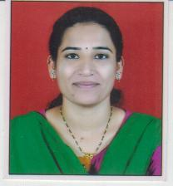

Name | Ms. Shital Baliram Sonawane
Department: | Applied science & Mathematics
Designation | Assistant Professor
Email: | sb-sonawane@kkwagh.edu.in
Education | M.Sc , B.Ed
Experience | 06 years
Research Area(s) | -
Publications: Paper/Copyright/Patent/Grant received | -
Contents developed | -
Membership of professional bodies | -
Awards | -
Key Research Projects | -

